Exercise Solution

Task - 01
Modify the program to swap the values of three characters (A, B, and C). Write the modified assembly code and explain the changes you made.

INPUT:

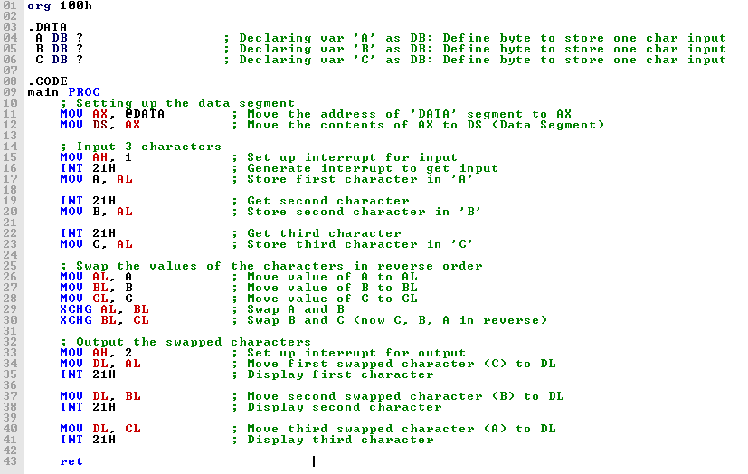

EXPLANATION:

In this program, added a third variable `C` to store a third character input from the user, as we wanted to handle three characters instead of two. The code now accepts three inputs and reverses their order. After gathering the input, the `XCHG` instruction is used to swap the values of the variables. First, swapped `A` and `B`, and then swapped `B` with `C`, effectively reversing the order of all three characters. Once the values are swapped, the characters are displayed in the new (reversed) order using interrupts for output. The changes focus on extending the original logic to handle an additional character and swap all three inputs efficiently.

OUTPUT:

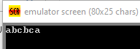

Task – 02
Modify the program to accept a 4-character string from the user. Reverse the characters (e.g., input:
"ABCD", output: "DCBA") and display them in reverse order. Write the assembly code for this program.

INPUT:

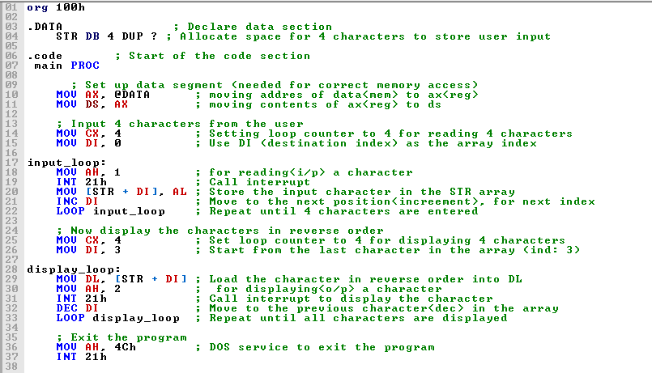

EXPLANATION:
The assembly code begins by declaring a variable `STR` in the data section to store a 4-character string from the user. It sets up the data segment for proper memory access and then enters an input loop, where it reads each character and stores it sequentially in the `STR` array using the index register `DI`, which starts at 0 and increments after each input. After collecting all characters, the code enters a display loop that starts from the last character (using `DI` initialized to 3) and decrements the index to print the characters in reverse order. Finally, the program exits

OUTPUT:
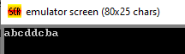

Task-03
Explain the difference between using XCHG and manually moving values between registers and memory locations

The `XCHG` instruction in assembly language swaps the values of two operands directly, allowing for a more efficient exchange of data without the need for an intermediate register. This is particularly useful when dealing with two registers or a register and a memory location, as it simplifies the code and reduces the number of instructions required. In contrast, manually moving values between registers and memory locations typically involves multiple steps, such as first moving a value to an intermediate register before transferring it to the target location. This process can be more verbose and less efficient, as it requires additional instructions and can increase the overall execution time. Using `XCHG` streamlines the operation, making the code cleaner and potentially improving performance.

